

ShopNest Power BI Capstone Project

Dashboard Report

Date: 25/05/2025

Author: Bankupalli. pradeep kumar

**Introduction:**

Shop Nest stands as the leading department store in the e-commerce marketplaces in Portugal. Serving as a seamless link, it connects small businesses from various regions in Portugal to channels, streamlining the process with a single point of contact. Through the Shop Nest Store, these merchants can showcase and sell their products, with the added convenience of direct shipment to customers facilitated by Shop Nest logistics partners. The provided data represents authentic commercial information that has undergone the process of anonymization.

**Findings:**

A comprehensive Power BI Dashboard had been created to address the key business analytics for a retail Dataset. Below are the key issues, Visualization and the Explanation for the same.

**Question Statement 1:**

Identify and Visually represent the top 10 product categories by Total Sales.

**Visualization:**

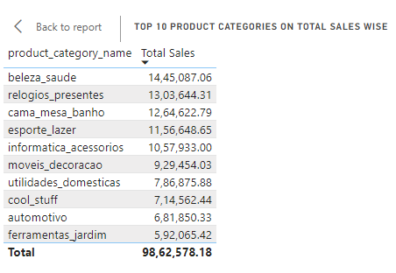

**Explanation:**

A Table Chart showing summary of the Top 10 Product categories based on their total sales.

1. **Highest Sales:**
   * The “Beleza_Saude” (Beauty and Health) Category has the highest total sales amounting to €**14,45,087.06**
2. **Second Highest Sales:**
   * The "Relogios_presentes” (Watches & Gifts) follow with **€13,03,644.31** has the second highest total sales amounting.
3. **Middle Tier Sales:**
   * In Middle range we can 4 product categories like:
4. “Esporte_lazer” (Sports & leisure) amounting **€11,56,648.65.**
5. “Informatica_acessorios’’ (Computer Accessories) amounting **€10,57,933.00.**
6. “Moveis_Decoracao’’ (Furniture & Decoration) amounting **€9,29,454.03.**
7. “Utilidades_Domesticas” (Household Utilities) amounting **€7,86,875.88**
8. **Lowest Sales:**
   * The “Ferramentas_Jardim” (Tools and Garden) which is the lowest sales in the top 10 Product Category with **€5,92,065.42**

**Summary:**

* Overall, this data is used to identify high performing categories to allocate more resources or expand offerings.
* Recognizing Lower-performing Categories for potential improvement or strategic changes.
* Making data-driven decision for inventory management, marketing, and promotions.

**Question Statement 2:**

Determine the number of delayed orders in each category. An order is considered delayed if the actual delivery date is later than the estimated delivery date.

**Visualization:**

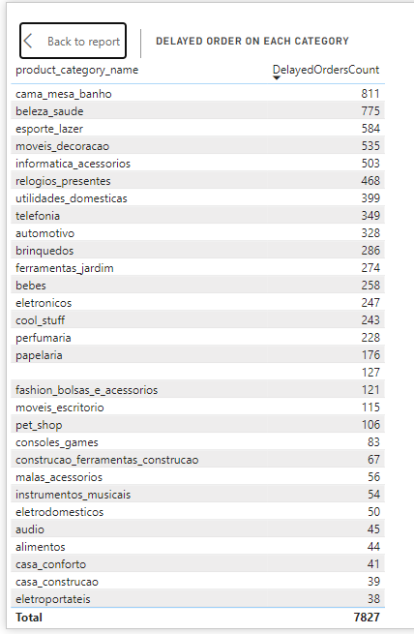

**Explanation:**

A Table showing Delayed order count on each product category wise.

**Total Delayed Orders:**

* The total number of delayed orders across all categories is 7827.

**Top 5 Delayed orders**

* Casa Conforto is the top most delayed orders of 811.
* Beleza_saude is the 2nd most delayed orders of 775.
* Esporte_Lazer is the 3rd most delayed orders of 584.
* Moveis_Decoracao is the 4th most delayed orders of 535.
* Informatica_acessorios is the 5th most delayed orders of 503.

**Bottom 5 delayed Orders:**

* Artigos_De_Festas, Flores, fraldas_Higiene and portateis_cozinha_e_preparadores_de_alimentos are having only 1 delayed order for each category.
* Artes_e_artesanato is 2 delayed orders.

**Summary**

* We have totally 7827 delayed order for over the month. We have order was delayed automatically the customer satisifaction we will decrease.
* In the delayed area we have increase the service to reach the order on time for the customers.
* More over we need to focus on the high delayed products.

**Question Statement 3:**

Create a dynamic visual that compares the number of delayed orders to the number of orders received earlier for each month.

**Visualization:**

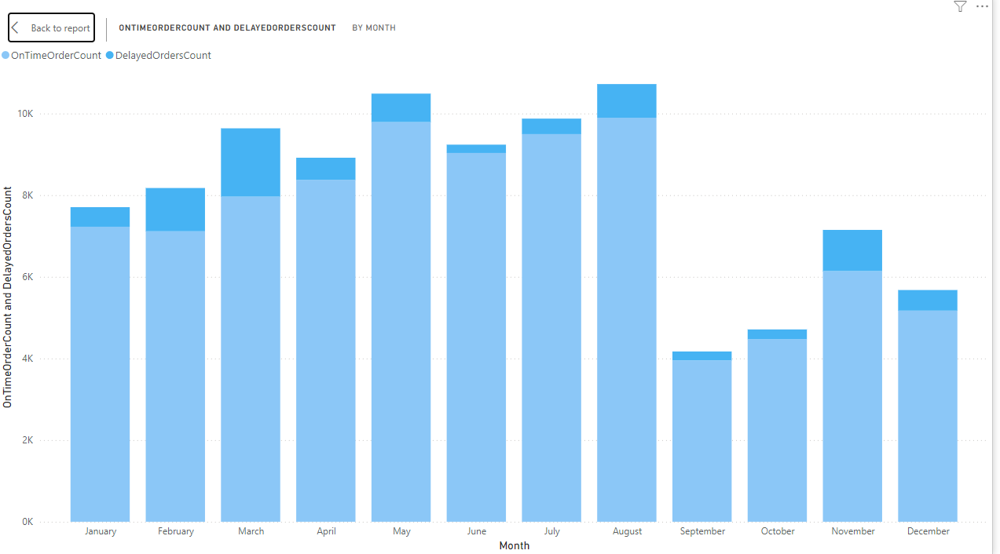

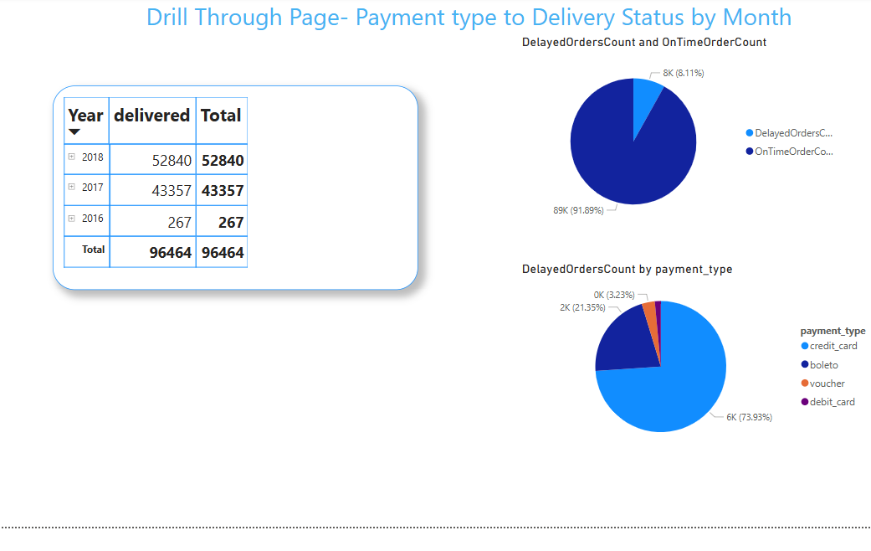

**Explanation:**

A Bar Chart with On-time and delayed order deliveries created along with drill through feature. A Matrix with count of delivers added based on Delivered date with late and on-time deliveries created and Pie charts showing On-time and delayed delivery and the same based on payment type created for more detailed analysis. Below are the insights for the same:

1. **Overall Trends**:

* **On-Time Orders** consistently outnumber **Delayed Orders** in every month, with a notable margin.
* The month of **August** has the highest number of On-Time Orders, at **9,897**.
* **March** has the most delayed orders, with **1,673**.

1. **Monthly Peaks**:

* **August** also shows a high number of On-Time Orders (**9,897**) but with a significant count of delayed orders (**824**), reflecting a higher variance compared to other months.
* **June** has a notably low count of delayed orders (**204**) despite being one of the higher On-Time months with **9,033** On-Time Orders.

1. **Fluctuations**:

* There’s a visible dip in order counts in **October** and **September**, with **4,475** and **3,953** On-Time Orders, respectively.
* There is a noticeable recovery in **November** and **December** as On-Time Orders rise to **6,140** and **5,172**, respectively, but the delayed orders in **November** peak significantly.

1. **Lowest Delayed Orders**:

* The month of **June** has the lowest delayed orders at **204**, suggesting an efficient month for on-time deliveries.

1. **General Efficiency**:

* The delayed orders never surpass **20%** of the total for any given month, indicating a strong overall efficiency in deliveries, with most months performing consistently well.

**Question Statement 4:**

Analyze the most frequently used payment methods by customers using a visually appealing representation such as pie chart or other suitable visuals.

**Visualization:**

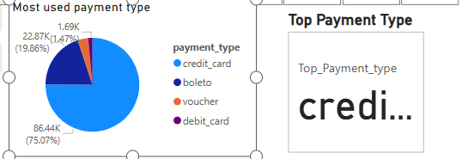

**Explanation:**

Two Visuals created to showcase most commonly used payment type. A pie chart with all the payment types and a Card showing the most used payment type in terms of number of orders. Here are some insights:

1. **Most Used Payment Type**:
   * **Credit Card**: Dominates with 75.07% usage.
   * **Boleto**: Comes next with 19.86%.
   * **Voucher**: Used by 3.6% of users.
   * **Debit Card**: Least used at 1.47%.
2. **Top Payment Type**:
   * The bar highlights that **Credit Cards** are the most popular payment method.

This data suggests that Credit Cards are the preferred payment method by a significant margin.

**Question Statement 5:**

Determine the Top 10 highest-rated products and the bottom 10 Lowest-rated products using bar chart or column chart.

**Visualization:**

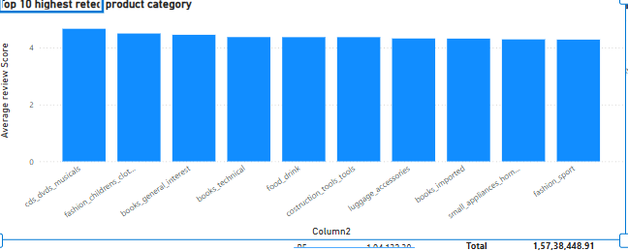

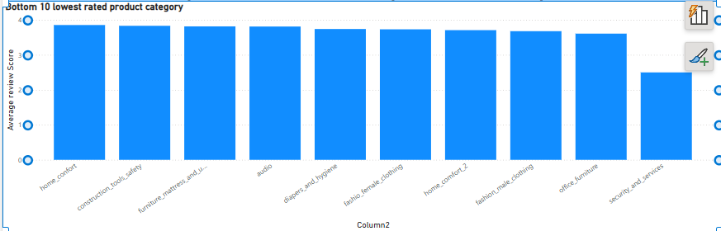

**Explanation**:

The above Stacked column chart shows the various product categories and their top 10 corresponding rating score

1. **Highest Rated category:**

* **CD’s, DVDs, Musicals** category has the highest review score of **4.67**. This indicating that customers are very most satisfied product category.

1. **Second High Rated Category:**

* **Fashion, Children’s Clothes** category has the second highest review score of **4.50**.
* This category also receives a high rating, suggesting positive customer feedback, through slightly lower than CD’s, DVDs, Musicals Category.

1. **Middle rated Category on top 10:**

* Categories such as **Books_General_Interest (4.46)**, **Books_Technical (4.37)**, **Food_Drink (4.37)**, **Construction_tools (4.37)**, **Luggage_Accessories (4.32)**, **Books_Imported (4.32).**
* All these 6 product categories have the middle rated on top 10 products
* It shows generally positive feedback but there may be room for minor improvement to get high satisfaction from customers.

1. **Lowest Rated category on top 10:**

* **Small_Applicances_Home_Oven_and_Coffee** and **Fashion_Sport** is the lowest Top 10 rated product category of **4.29**.
* But still maintaining satisfactory feedback. The slightly lower scores suggest there are specific areas where customer expectations aren’t fully met.

1. **Bottom Rated Category**:

* **Security_Services** as **2.50** has the lowest review score among all the product category. This reflecting significant dissatisfaction. Likely concerns include poor service reliability inadequate product quality or unfulfilled expectations. The large gap between this score and other indicated urgent improvement needed.

1. **Second bottom rated category:**

* **Office_Furniture** is the second lowest score product categories which secure **3.61**
* Office_Furniture scores low, potentially due to issue like lack of ergonomic features, assembly difficulties, or inadequate difficulties, or inadequate durability. Customers may feel the quality does not justify the price,

1. **Middle rated Category on bottom 10:**

* Categories such as **Fashion_male_clothing** **(3.68),** **Home_comforts_2 (3.71)** **Fashion_Male_Clothing (3.73)**, **Diapers_And_Hygiene (3.74)**, **Audio (3.81)**, **Furniture_Mattress_And_Upholstery (3.82)**.
* All these 6 product categories have the middle rated on bottom 10 products.
* All these 6 shows moderate satisfaction, indicating potential for improvement in quality, fit, or usability.

1. **Top Rated category on bottom 10:**

* **Construction_Tools_safety** is the second top rated product category on bottom 10 rated as **3.83**.
* **Home_Comfort** is the top-rated product category on bottom 10 rated as **3.86**.

**Question Statement 6:**

Identify and visually represents states with high and low sales, providing a clear understanding of regional sales performance.

**Visualization:**

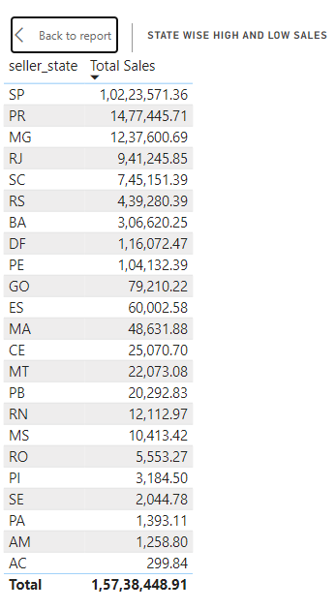

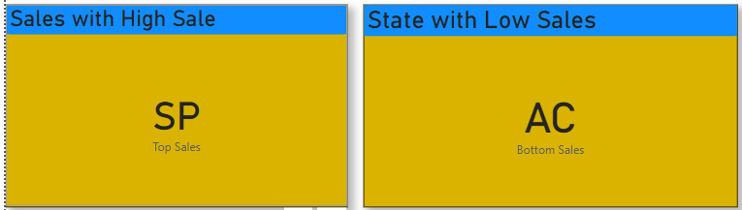

**Explanation:**

The above table shows the total sales for the individual states. Totally the shop nest is delivering their products to **23 States**. A significant portion of the sales is concentrated in a few states, indicating potential regional disparities.

1. **Highest sales Contributing State**:

* **SP** State has the highest sales of **1,02,23,571.36**
* Only **SP** State was contributing 64.37% majority of sales.

1. **Second Highest Sales Contributing State:**

* **PR** states is the second highest sales contributing **14,77,445.71**
* Percentage of total sales is **9.3%**
* **RJ** has the second highest sales but trails significantly behind **SP.**

1. **Lowest Sales Contributing Sales:**

* **AC** State has lowest sales compared to other states as **299.84**
* Percentage of totalsales is <0.01%
* This AC state reflecting a very small market size.

**Insights:**

1. **Highly Concentrated Sales:**

* Over 85% of total sales are concentrated in the top 5 states (SP, PR, MG, RJ, SC).
* SP dominated with nearly two third of the total Sales.

1. **Opportunities Growth:**

* Low performing states may represent untapped markets. However, future analysis of population, infrastructure, and purchasing power is necessary to understand potential.

1. **Regional Disparities:**

* The bottom 5 states together contribute less than 0.05% of total Sales.
* This indicates cast economic or market difference between regions.

**Summary:**

This data underscores the need for targeted strategies to maintain strong performance in high-revenue regions while exploring untapped potential in lower-performing states.

**Question Statement 7:**

Investigate and visualize any seasonal patterns (quarterly) or trends in sales data over the course of year.

**Visualization:**

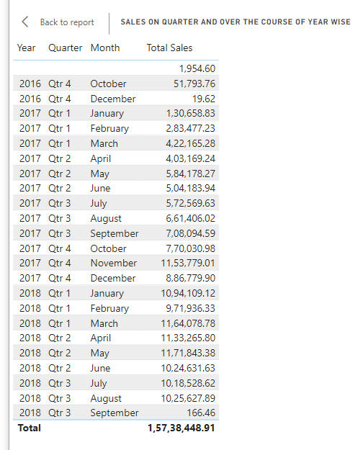

**Explanation:**

1. **Highest Year for total Sales:**

* In **2018** we can see more sales as **86,04,188.01.**
* In **2018** the company sales were more on overall the years.

1. **Lowest year for total Sales:**

* The year with the lowest total sales is 2016 as 51,813.38 which has the smallest total sales across all years.

1. **Middle Year for total Sales:**

* The Middle year, by comparison is 2017 as 70,80,492 as its falls between the highest (2018) and (2016).

1. **Total Sales as per Quarter:**

* We look at the sales in each quarter and find that the highest sales occurred in Quarter 2 of 2018 as 33,29,740.81
* The lowest sales occurred in Quarter 4 2016 as 51,813.38 which is a significant smaller amount compared to the other quarter.
* The middle quarter based on sales is Quarter 1 of 2017 8,36,301.34 as it falls between highest and lowest quarters.

**Summary:**

This process helps identify the top performing and lowest performing periods (both annually, and quarterly) in terms of sales.

**Question Statement 8:**

Determine the total revenue generated by shop nest store and analyse how it changes over time (Yearly). Represent this information through suitable visuals to highlight trends and patterns.

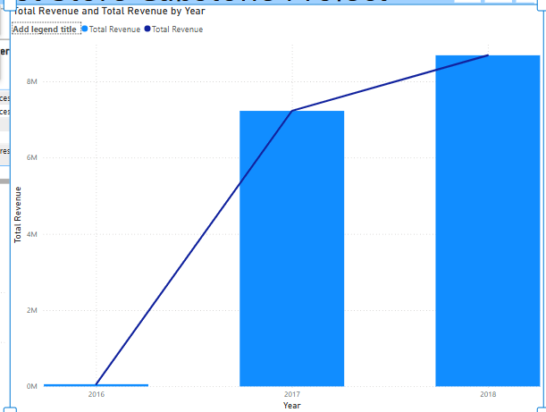

**Explanation:**

1. **2016:**

* In **2016** we can the company just started the business so the revenue in 2016 was low as compared with across all the year as **51,813.38.**
* It could represent that either total revenue for 2016 in a particular currency or the total revenue from multiple sources.

1. **2017:**

* In **2017** total revenue was **70,80,492.92**
* This is a significant increase compared to 2016, indicating growth in revenue.

1. **2018:**

* Total revenue in 2018 was **86,04,188.01**
* Another increase compared to 2017, but the growth rate seems to slow down when compared to the jump between 2016 and 2017.

**Summary:**

* The sum of revenues for **2016**, **2017** and **2018** was **1,57,38,448.91** means overall revenue for all 3 years was high.
* This show that the company was increase with revenue for every year.
* If it increases its goods and service in all the states the revenue will more.

*********************************END OF THE REPORT********************************